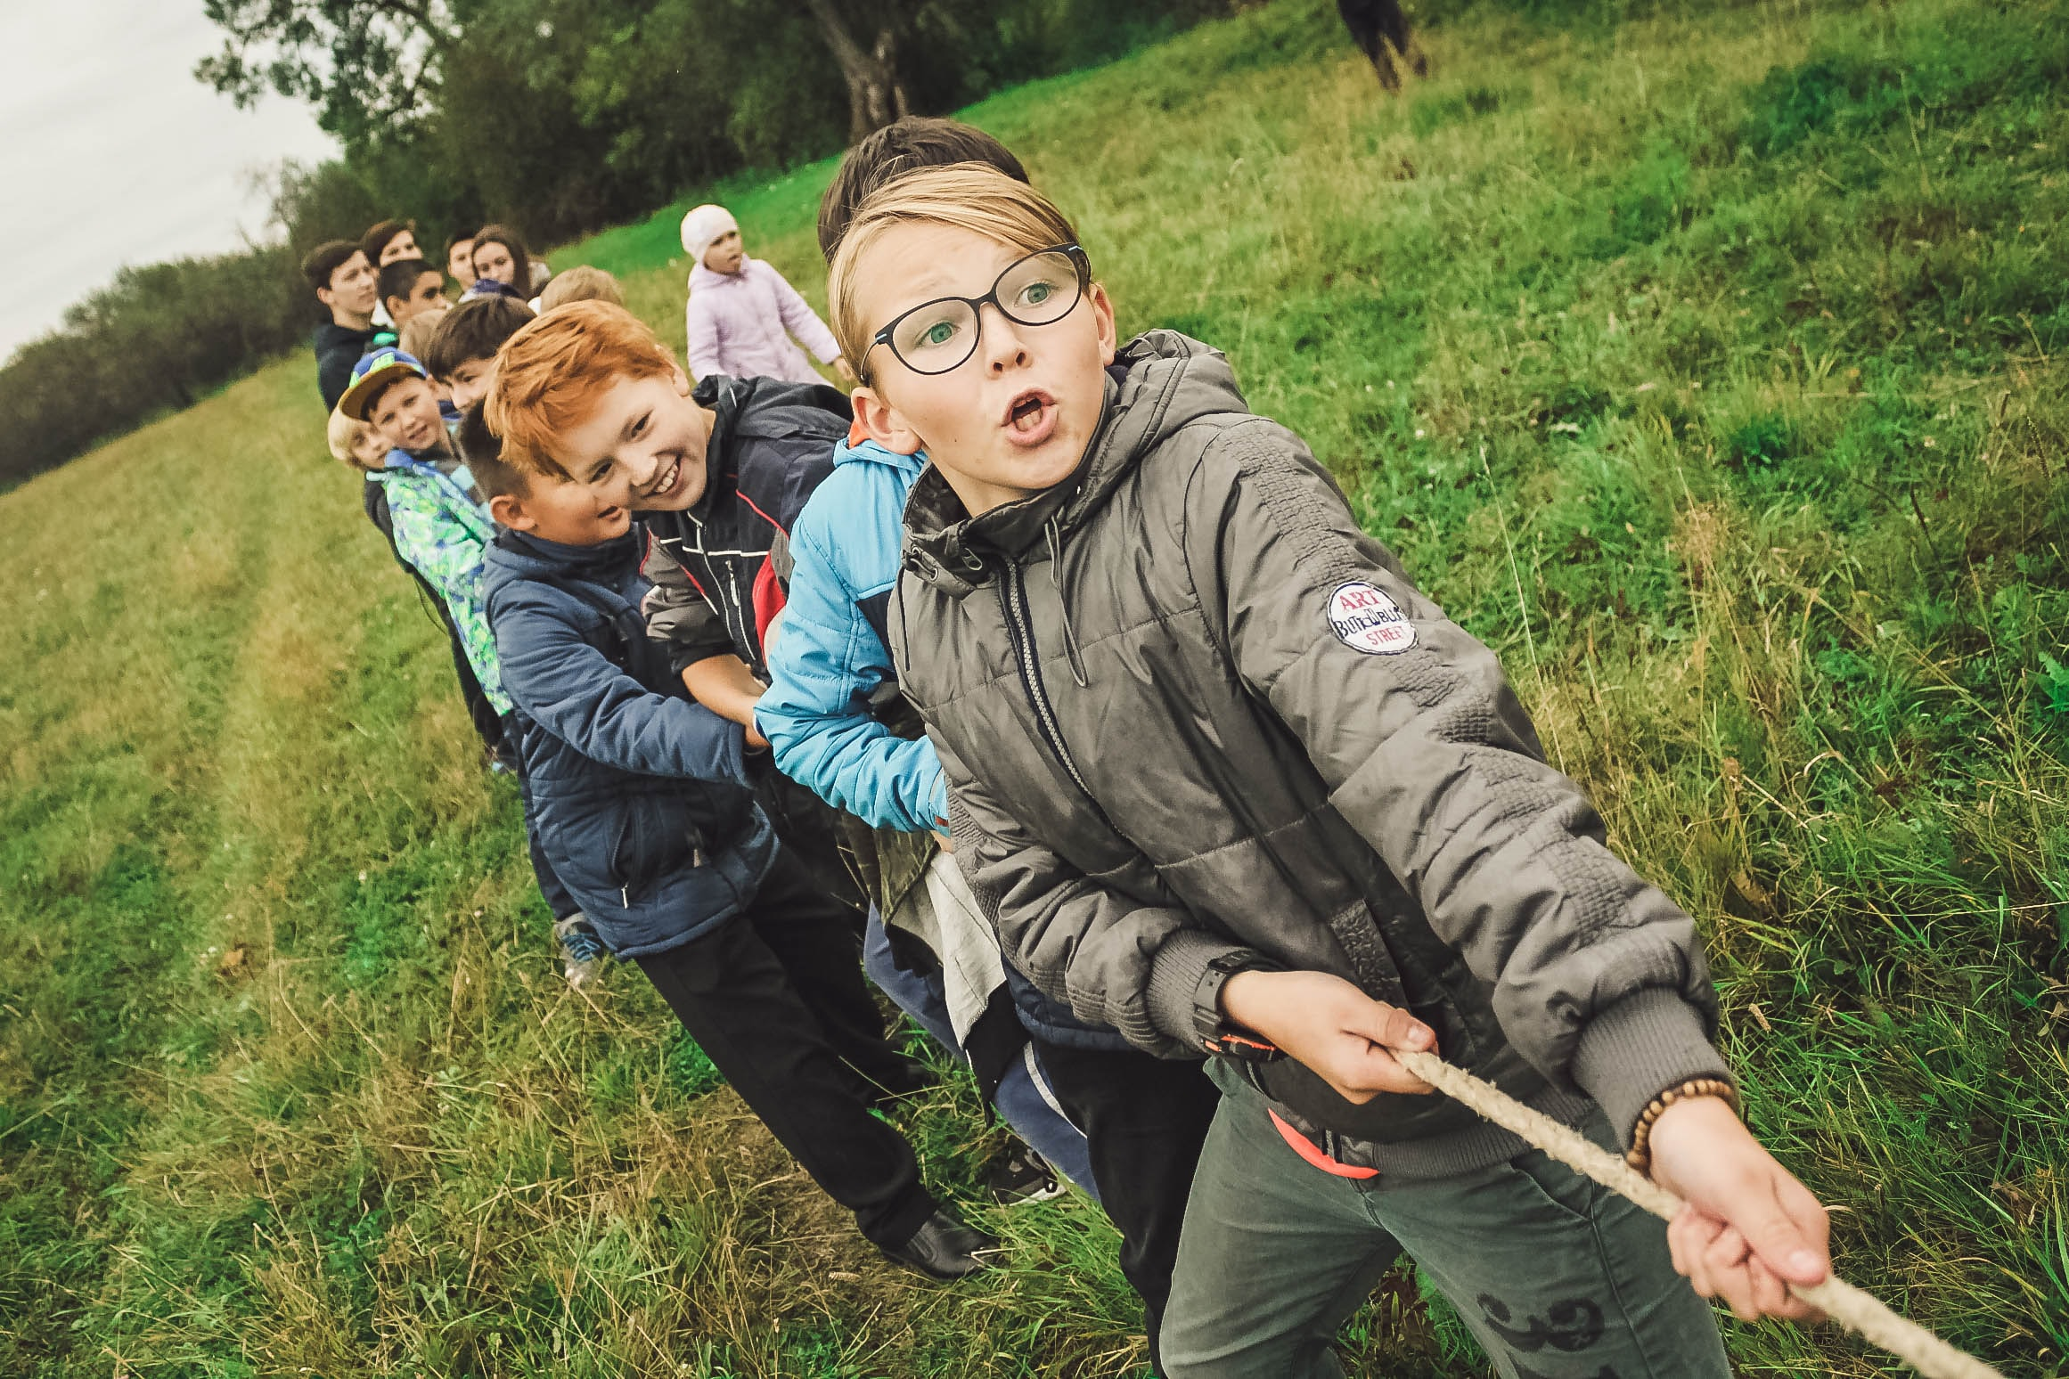

June 2024

SCHOOL SUCCESS PLAN
Windermere Elementary School
Principal Message
Windermere Elementary School is a K -7 school located in the beautiful East Kootenay hamlet of Windermere, BC. WES is a part of School District #6 –Rocky Mountain and we are honored to work and play on the traditional lands of the Ktunaxa and Shuswap Peoples.  With strong links to our community and beautiful Lake Windermere only minutes away, the rural setting of our school makes it a student centered and connected place to learn.  Due to the size of our school, many of our classes are combined. WES staff has embraced this ongoing arrangement as an excellent means to provide inclusive education to our students. We work closely as a team to make decisions on how to best support students and our partners and outside agencies are an important part of the support we offer to students.  With a focus on collaboration, WES staff meet each month to review progress and plan for next steps in student growth. We use the School Success plan as a roadmap for assessing our strategies and needs for ongoing growth in the priority areas. The team analyzes all forms of data; ministry, district and school based to make decisions on next steps for student growth in learning.  The WES team is committed to ongoing professional growth in understanding how to best support the needs of our students.  Looking ahead to a connected and successful school year!  Ms. Keri Gust,  Principal | 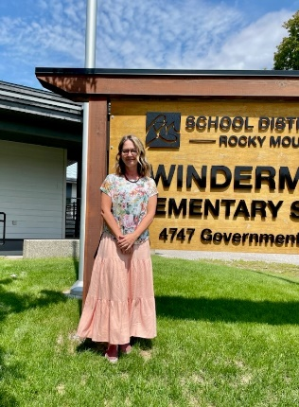  

school demographics
Staff  - 10 Classroom teachers  - 1 Learning Services Teacher  - 1 Teacher-librarian  - 7 Education Assistants  - 1 Indigenous Education Student Support Worker  - 1 Admin Assistant  - 1 Principal | Students  - 175 students  - 31 Indigenous students
Grades  - Kindergarten - 18  - Grade K/1 - 17  - Grade 1/2 - 20  - Grade 2/3 - 20  - Grade 3/4 - 21  - Grade 4/5 - 25  - Grade 5/6 - 26  - Grade 6/7 - 27 | 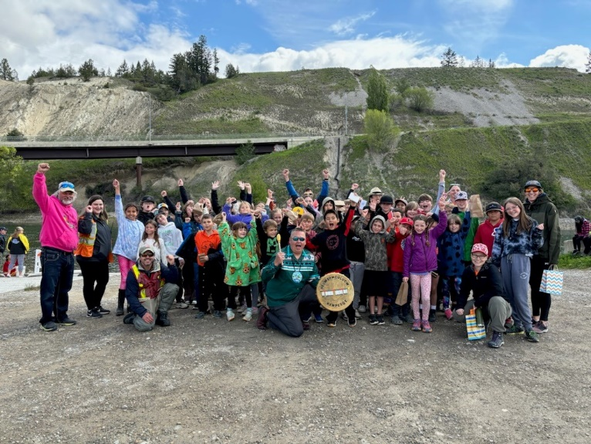

Vision | mission
A safe place to learn and grow. | To build a connected community of resilient, engaged learners
values
SAFETY (to take risks and meet challenges)  PERSEVERENCE (The 'I can do it' Spirit)  CONNECTION (to oneself, the school and community)  JOY AND CURIOSITY |  | 

thematic narrative
Throughout the spring 2024, WES staff engaged in a thorough examination of benchmark, classroom and report card data in social emotional, literacy and numeracy learning to plan for student supports throughout the 2024-25 school year. Monthly examination of student writing and math task samples by staff, demonstrated growth across K-7 in student's ability to make connections between text and personal experiences in both numeracy and literacy. This supported reading comprehension and the ability to complete multi step math tasks for students.  Historically, WES students have performed well in foundational literacy and numeracy skills. The results from data collected in May 2024 continue to show the team that students are supported in learning foundational literacy and numeracy skills.  *64% of students grades 1-7 achieved proficient on the district numeracy benchmark, only 5% were emerging in basic skills in math (SNAP)  *60% of students grades K-3 achieved proficient on the district reading benchmark (PM), with a higher percentage of emerging students at 25%  In regards to social and emotional learning, teachers collected playground and classroom management data and observed that students struggled to make connections between personal and social behavior and well-being. Student behaviour during unstructured time is an area of weakness and this aligns with our academic data - students are not able to persevere through difficult social, emotional and academic problem solving without support. The team wishes our students to feel more confident and demonstrate agency over their learning and success at school.  Due to a curiosity from the team on why our students could learn foundational skills, but were not as successful in application, analysis, synthesis, and deeper comprehension, staff noted a common learning trait that was negatively impacting student achievement. Students did not demonstrate they had agency over their learning. Learning was more of a passive experience than active and achieving a proficient grade did not seem to be a strong goal for students. Families were also reporting a disconnect in how to support their students. Knowing that leveraging family and community partnerships is essential in supporting student growth and learning, WES staff want to strengthen these relationships through clear communication of what students are learning, and how they can be proficient in their learning with next steps.  I took these team findings to the WES Parent Advisory Committee in April and May and parents agreed that these trends were important to address. Other feedback from PAC members included: continue to foster family connection at school, provide options and multiple entry points for students to show their learning, ongoing partnerships to facilitate outdoor and hands-on learning for students, and celebrating student growth and achievement with families and community. This feedback is evident in our inquiry for all four priority areas.  The WES team, using clearly communicated learning intentions, success criteria and goal setting structures, wishes to see student agency, resilience, advocacy and responsibility in learning improve throughout the school year. Staff and students will be setting goals, working toward proficient in the success criteria, looking at results to reflect on next steps in an iterative cycle of learning progression.  Goal  To increase students' ability to solve complex problems to persevere in difficult situations, and exercise responsibility, which will result in higher achievement in literacy, numeracy and SEL. |   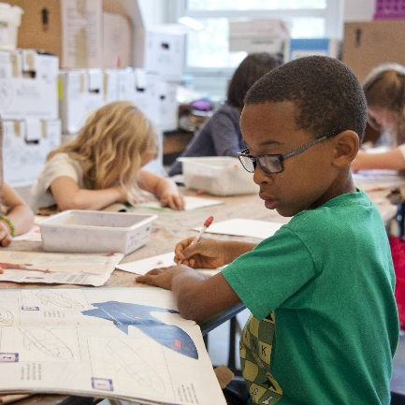  

equity, Diversity and Inclusion
To increase students ability to solve complex problems to persevere in difficult situations, and exercise responsibility, which will result in higher achievement in literacy, numeracy and SEL

Inquiry  If the school team clearly communicates playground expectations for problem solving, will we see a decrease in behaviors during unstructured times. | Action  Explicit messaging from the team of what is appropriate/not appropriate to students and parents (weekly email)  Tracking of inappropriate language and a supported recess response with communication home and a consistent approach to supporting students (Supported Recess.  Monthly Pillar Assembly (making meaning)

Data and Monitoring
Recess behavior tracking
Team approach to addressing behaviour:
*Supported Recess
*Weekly Problem of the Week

success for each learner
To increase students ability to solve complex problems to persevere in difficult situations, and exercise responsibility, which will result in higher achievement in literacy, numeracy and SEL
Inquiry  If the team clearly communicates learning intentions and success criteria to students and parents, will students demonstrate higher achievement on school assessments and benchmarks. | Action  Staff will communicate assessment practices with home - weekly/biweekly  Teachers will teach about and demonstrate, learning intentions and success criteria with students daily and share criteria with families.

Data and Monitoring
Fall, Winter, Spring Feedback
1. Teacher reflections
Fall and Spring benchmark data - growth from October-May

Growing Capacity of Self and Others
To increase students ability to solve complex problems to persevere in difficult situations, and exercise responsibility, which will result in higher achievement in literacy, numeracy and SEL
Inquiry  If staff have a better understanding of assessment literacy, they will be able to show student growth to students and families more successfully. | Action  Monthly examination of classroom data artifacts during Intervention meetings - plan for next steps  Create school based monitoring tools to determine student growth in solving problems.

Data and Monitoring
*Staff self-reflection - Record teacher growth throughout school year through reflections (2 x per year)
*Collect and share student samples of goal setting and achievement (2 x per year)

Stewardship for the Future

Inquiry  By participating in field trips to local community partners to strengthen relationships, will students demonstrate better ways to take care of the environment. | Action  -Each class will meet monthly with an elder, knowledge keeper or community member to learn about ways to take care of the environment we live in.  -Students will reflect three times on how they connect to their community in relation to taking care of this place.  4 school wide Outdoor Learning field days with assessment  Pillar Assemblies - invite community members in to share about resilience.

Data and Monitoring
Post Learning Celebration (May)- staff will reflect on learning and growth and plan for next steps
How Many Times data (teacher survey eg. visited community, had community in, local Indigenous partners)
Student reflections - 3x/year

